

| **TITLE: Matplotlib library in Python** |
| --- |

**AIM:** Write a program to explore the Matplotlib library

**____________________________________________________________________**

**Expected OUTCOME of Experiment:** To demonstrate Matplot library in python

**______________________________________________________________________**

**Resource Needed: Python IDE**

**______________________________________________________________________**

**Theory:**

## What is Matplotlib?

| 1. Matplotlib  Matplotlib is a data visualization library and 2-D plotting library of Python It was initially released in 2003 and it is the most popular and widely-used plotting library in the Python community. It comes with an interactive environment across multiple platforms. Matplotlib can be used in Python scripts, the Python and IPython shells, the Jupyter notebook, web application servers, etc. It can be  used to embed plots into applications using various GUI toolkits like Tkinter, GTK+, wxPython, Qt, etc. So you can use Matplotlib to create plots, bar charts, pie charts, histograms, scatterplots, error charts, power spectra, stemplots, and whatever other visualization charts you want! The Pyplot module also provides a MATLAB-like interface that is just as versatile and useful as MATLAB while being free and open source.  2. Plotly  Plotly is a free open-source graphing library that can be used to form data visualizations. Plotly (plotly.py) is built on top of the Plotly JavaScript library (plotly.js) and can be used to create web-based data visualizations that can be displayed in Jupyter notebooks or web applications using Dash or saved as individual HTML files. Plotly provides more than 40 unique chart types like scatter plots, histograms, line charts, bar charts, pie charts, error bars, box plots, multiple axes, sparklines, dendrograms, 3-D charts, etc. Plotly also provides contour plots, which are not that common in other data visualization libraries. In addition to all this, Plotly can be used offline with no internet connection |
| --- |

## Plotting x and y points

The plot() function is used to draw points (markers) in a diagram.

By default, the plot() function draws a line from point to point.

**Syntax:**

matplotlib.pyplot.plot(\*args, scalex=True, scaley=True, data=None, \*\*kwargs)

* x, y: These parameter are the horizontal and vertical coordinates of the data points. x values are optional.
* fmt: This parameter is an optional parameter and it contains the string value.
* data: This parameter is an optional parameter and it is an object with labelled data.

Returns:

This returns the following:

**lines :** This returns the list of Line2D objects representing the plotted data.

### Example:-

| **Draw a line in a diagram from position (1, 3) to position (8, 10):** | **Output** |
| --- | --- |
| import matplotlib.pyplot as plt import numpy as np  xpoints = np.array([1, 8]) ypoints = np.array([3, 10])  plt.plot(xpoints, ypoints) plt.show() | https://www.w3schools.com/python/img_matplotlib_plotting1.png |

## 1) Multiple Points

You can plot as many points as you like, just make sure you have the same number of points in both axis.

| **Program:**  import matplotlib.pyplot as plt import numpy as np  xpoints = np.array([1, 2, 6, 8]) ypoints = np.array([3, 8, 1, 10])  plt.plot(xpoints, ypoints) plt.show() | **Output:--** |
| --- | --- |

## 2) Matplotlib Line

## Linestyle:--- You can use the keyword argument linestyle, or shorter ls, to change the style of the plotted line:

Following are the linestyles available in ***matplotlib*:**

**Using *linestyle* Argument:**

* Solid
* Dashed
* Dotted
* Dashdot
* None

| **Syntax:** plt.plot(xdata, ydata, linestyle='dotted') | |
| --- | --- |
| **Program** | **Output:** | |
| **Use a dotted line:**  import matplotlib.pyplot as plt import numpy as np ypoints = np.array([3, 8, 1, 10]) plt.plot(ypoints, linestyle = 'dotted') plt.show() |  | |

## 3)Matplotlib Labels and Title

## a.Create Labels for a Plot

With Pyplot, you can use the xlabel() and ylabel() functions to set a label for the x- and y-axis.

The xlabel() function in pyplot module of matplotlib library is used to set the label for the x-axis.

| **Syntax:** matplotlib.pyplot.xlabel(xlabel, fontdict=None, labelpad=None, **kwargs) |
| --- |

## b. Create a Title for a Plot

With Pyplot, you can use the title() function to set a title for the plot.

| **Program:--**  import numpy as np import matplotlib.pyplot as plt  x = np.array([80, 85, 90, 95, 100, 105, 110, 115, 120, 125]) y = np.array([240, 250, 260, 270, 280, 290, 300, 310, 320, 330])  plt.plot(x, y)  plt.title("Sports Watch Data") plt.xlabel("Average Pulse") plt.ylabel("Calorie Burnage")  plt.show() | **Output:--** |
| --- | --- |

## 4) Matplotlib Scatter

## Creating Scatter Plots

With Pyplot, you can use the scatter() function to draw a scatter plot.

The scatter() function plots one dot for each observation. It needs two arrays of the same length, one for the values of the x-axis, and one for values on the y-axis:

| Syntax:-- matplotlib.pyplot.scatter(x_axis_data, y_axis_data, s=None, c=None, marker=None, cmap=None, vmin=None, vmax=None, alpha=None, linewidths=None, edgecolors=None)   * **x_axis_data-** An array containing x-axis data * **y_axis_data-** An array containing y-axis data * **s-** marker size (can be scalar or array of size equal to size of x or y) * **c-** color of sequence of colors for markers * marker- marker style * **cmap-** cmap name * **linewidths-** width of marker border * **edgecolor-** marker border color * **alpha-** blending value, between 0 (transparent) and 1 (opaque)   Except x_axis_data and y_axis_data all other parameters are optional and their default value is None. Below are the scatter plot examples with various parameters. | |
| --- | --- |
| import matplotlib.pyplot as plt import numpy as np  x = np.array([5,7,8,7,2,17,2,9,4,11,12,9,6]) y = np.array([99,86,87,88,111,86,103,87,94,78,77,85,86])  plt.scatter(x, y) plt.show() | **Output:--** |

## Add Grid Lines to a Plot

With Pyplot, you can use the grid() function to add grid lines to the plot.

| import numpy as np import matplotlib.pyplot as plt  x = np.array([80, 85, 90, 95, 100, 105, 110, 115, 120, 125]) y = np.array([240, 250, 260, 270, 280, 290, 300, 310, 320, 330])  plt.title("Sports Watch Data") plt.xlabel("Average Pulse") plt.ylabel("Calorie Burnage")  plt.plot(x, y)  plt.grid()  plt.show() | **Output: ?** |
| --- | --- |

## 5) Display Multiple Plots

With the subplot() function you can draw multiple plots in one figure.

| subplot(nrows, ncols, index, **kwargs)  **The layout is organized in rows and columns, which are represented by the *first*and *second*argument.**  **The third argument represents the index of the current plot.** |
| --- |

| Program:-import matplotlib.pyplot as plt import numpy as np  #plot 1: x = np.array([0, 1, 2, 3]) y = np.array([3, 8, 1, 10])  plt.subplot(1, 2, 1) plt.plot(x,y)  #plot 2: x = np.array([0, 1, 2, 3]) y = np.array([10, 20, 30, 40])  plt.subplot(1, 2, 2) plt.plot(x,y)  plt.show() | **Output:--** |
| --- | --- |
| import matplotlib.pyplot as plt import numpy as np  #plot 1: x = np.array([0, 1, 2, 3]) y = np.array([3, 8, 1, 10])  plt.subplot(2, 1, 1) plt.plot(x,y)  #plot 2: x = np.array([0, 1, 2, 3]) y = np.array([10, 20, 30, 40])  plt.subplot(2, 1, 2) plt.plot(x,y)  plt.show() | **Output:--** |

## 6) Creating Bars

With Pyplot, you can use the bar() function to draw bar graphs.

| import matplotlib.pyplot as plt import numpy as np  x = np.array(["A", "B", "C", "D"]) y = np.array([3, 8, 1, 10])  plt.bar(x,y) plt.show() | **Output:--** |
| --- | --- |
| import matplotlib.pyplot as plt import numpy as np  x = np.array(["A", "B", "C", "D"]) y = np.array([3, 8, 1, 10])  plt.bar(x, y, color = "#4CAF50") plt.show() |  |

## 7) Creating Pie Chart with Labels:

| import matplotlib.pyplot as plt import numpy as np  y = np.array([35, 25, 25, 15]) mylabels = ["Apples", "Bananas", "Cherries", "Dates"]  plt.pie(y, labels = mylabels) plt.show() | **Output: ?** |
| --- | --- |

**Problem Definition**:

**Note:-- All plot should be labelled on X-axis and Y-axis with Grid for each program.**

1.Write a Python program to draw a line using given axis values with suitable label in the x axis, y axis and a title.

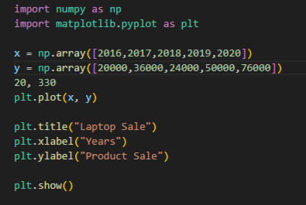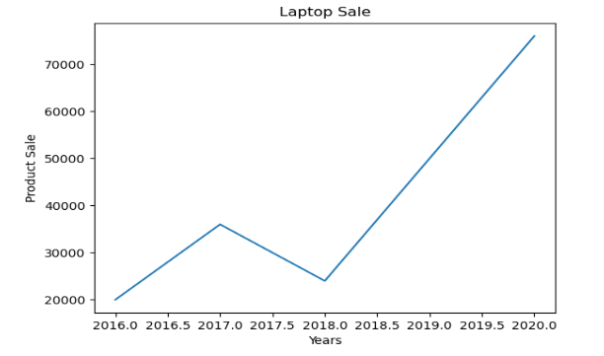

2. a)Write a Python programming to display a bar chart of the popularity of programming Languages. Also draw Pie chart for **popularity** Data values.

**Sample data:**

**Programming languages: Java, Python, PHP, JavaScript, C#, C++**

**Popularity: 22.2, 17.6, 8.8, 8, 7.7, 6.7**

**import matplotlib.pyplot as plt**

**import numpy as np**

**y = np.array([22.2, 17.6, 8.8, 8, 7.7, 6.7 ])**

**mylabels = ["Java", "Python", "PHP", "JavaScript","C#","C++"]**

**plt.pie(y, labels = mylabels)**

**plt.show()**

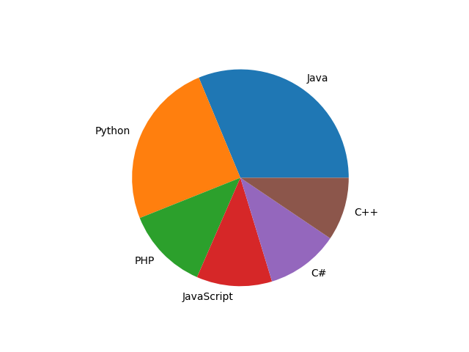

b) Write a Python program to display a horizontal bar chart of the popularity of programming Languages. **Hint: use the barh() function**

**import matplotlib.pyplot as plt**

**import numpy as np**

**x= np.array([22.2, 17.6, 8.8, 8, 7.7, 6.7 ])**

**y = ["Java", "Python", "PHP", "JavaScript","C#","C++"]**

**plt.title("Programming languages popularity")**

**plt.xlabel("Popularity")**

**plt.ylabel("Programming languages")**

**plt.barh(y, x, color = "#4CAF50")**

**plt.show()**

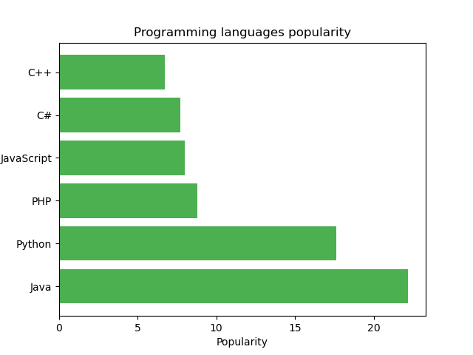

3)Prepare a dataset using list as **Weight** and **height** parameters for your batch students

and draw a scatter plot with appropriate label and title.

import matplotlib.pyplot as plt

import numpy as np

x= np.array([67, 87.6, 68.8, 68, 57.7, 96.7,48.6,74.8 ])

y = np.array([120,125,180,165,170,176,178.5,159.8])

plt.scatter(x,y)

plt.show()

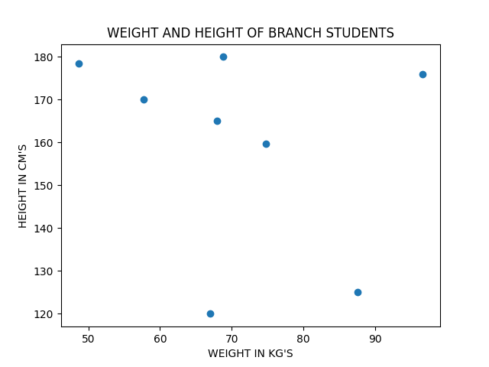

**Post Lab Questions:--**

1. Considering datasets of your choice, create and explain the utility of following charts:

| 1. Swarn chart 2. Pair chart 3. Pair grid 4. Facet Grid 5. Scatter plot | 1. Regression plot 2. Count plot 3. Bar plot 4. Violin plot 5. Heat map |
| --- | --- |

**1) A swarm plot is used to visualize the distribution of categorical data along with individual data points.**

**Ans)**

**import seaborn as sns**

**import matplotlib.pyplot as plt**

**data=sns.load_dataset("tips")**

**plt.figure(figsize=(10,8))**

**sns.swarmplot(x="day",y="total_bill",data=data)**

**plt.title=("Swarn chart of tatal bill amount by day")**

**plt.ylable=("Total bill amount")**

**plt.xlable=("Day of week")**

**plt.show()**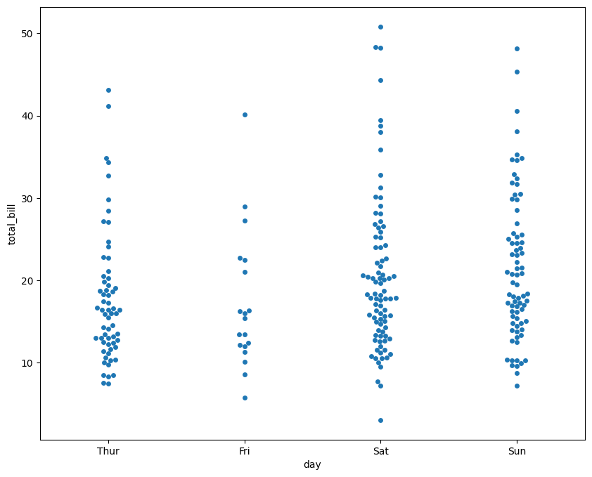

**2) A pair chart (also known as a scatterplot matrix) is used to visualize pairwise relationships between multiple variables in a dataset.**

**import seaborn as sns**

**import matplotlib.pyplot as plt**

**data=sns.load_dataset("iris")**

**sns.set(style="ticks")**

**sns.pairplot(data, hue="species")**

**plt.show()**

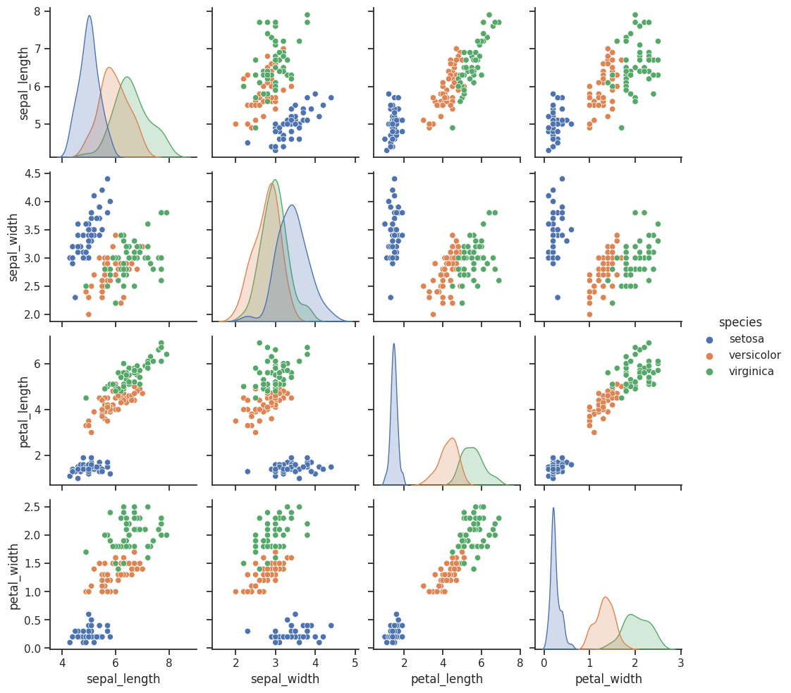

**3) A pair grid is an extension of the pair chart, allowing you to create scatterplot matrices for multiple subsets of your data.**

**import seaborn as sns**

**import matplotlib.pyplot as plt**

**data=sns.load_dataset("iris")**

**g=sns.PairGrid(data,hue="species")**

**g.map_upper(sns.scatterplot)**

**g.map_diag(sns.histplot)**

**g.map_lower(sns.kdeplot)**

**g.add_legend()**

**plot.show()**

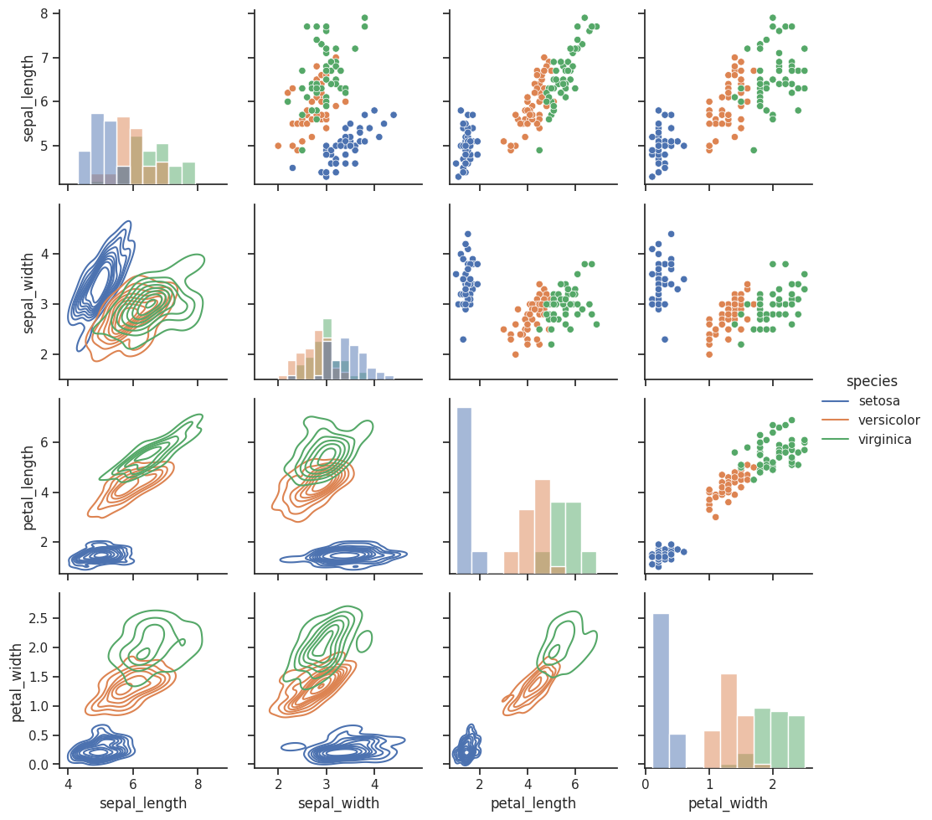

**4) A facet grid is a grid of subplots where each subplot displays a subset of the data based on a categorical variable.**

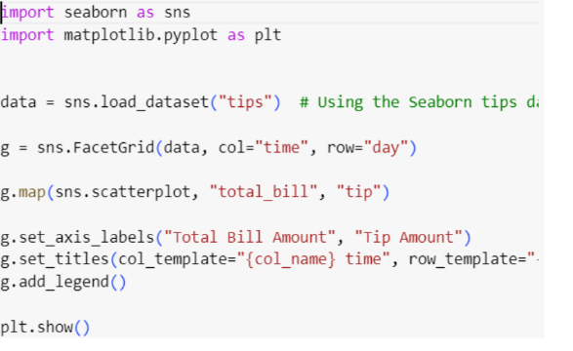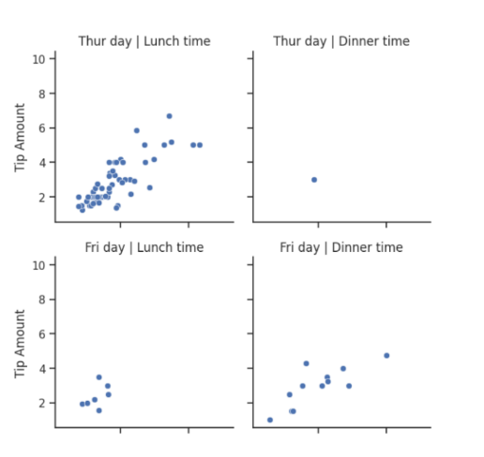

**5) A scatter plot displays individual data points as dots on a two-dimensional plane, with one variable on the x-axis and another on the y-axis**

**import seaborn as sns**

**import matplotlib.pyplot as plt**

**import numpy as np**

**y=np.array([40,30,45,68,75])**

**x=np.array([165,170,185,190,188])**

**plt.xlabel("WEIGHT IN (KG)")**

**plt.ylabel("HEIGHT IN (CM)")**

**plt.scatter(y,x,color="r",marker="*")**

**plt.grid()**

**plt.show()**

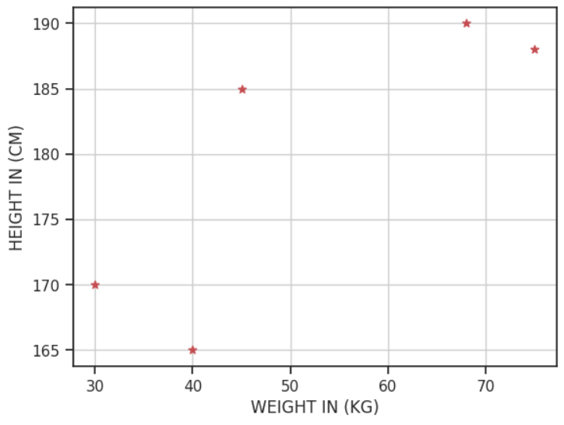

**6) A regression plot, often a linear regression plot, is used to visualize the relationship between two variables by fitting a linear regression line to the data points.**

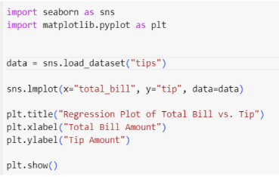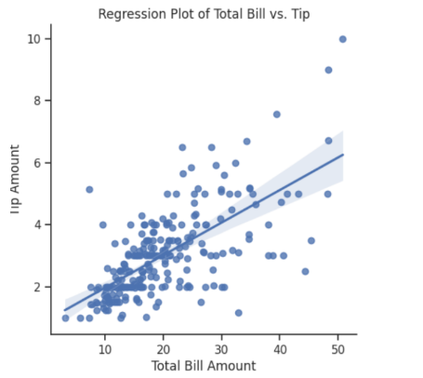

**7) A count plot is used to display the number of occurrences of each category within a categorical variable.**

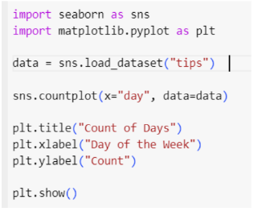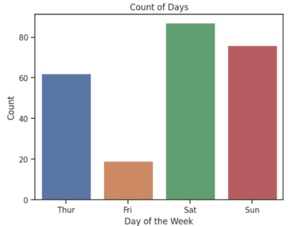

**8) A bar plot represents data using rectangular bars with lengths proportional to the values they represent.**

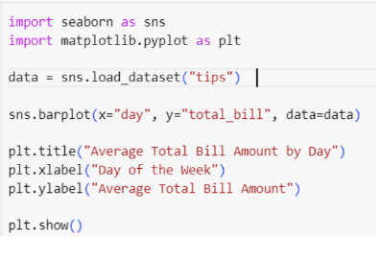

**9) A violin plot combines a box plot with a kernel density estimate to show the distribution of data, especially in terms of its shape and spread.**

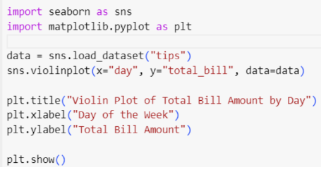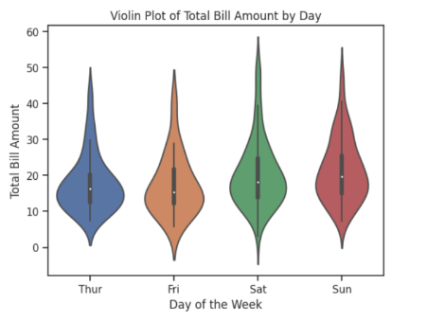

**10) A heat map is used to display data in a tabular format with colors representing the values in the cells.**

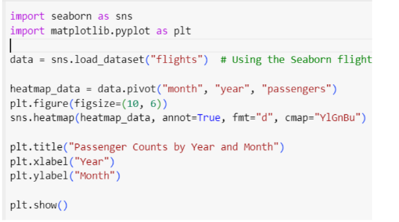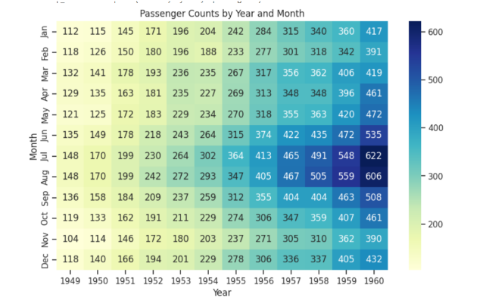

## What is Seaborn library? What are Different categories of plot in Seaborn.

Ans: Seaborn offers a variety of powerful tools for visualizing data, including scatter plots, line plots, bar plots, heat maps, and many more. It also provides support for advanced statistical analysis, such as regression analysis, distribution plots, and categorical plots.

The different types of plots in seaborn are:

1. distplot
2. Bar plot
3. Histogram
4. Scatter plot
5. Heat map

**Books/ Journals/ Websites referred:**

1. [Matplotlib Plotting (w3schools.com)](https://www.w3schools.com/python/matplotlib_plotting.asp) – Reference website.
2. Reema Thareja, Python Programming: Using Problem Solving Approach, Oxford University Press, First Edition 2017, India
3. Sheetal Taneja and Naveen Kumar, Python Programming: A modular Approach, Pearson India, Second Edition 2018,India

**Implementation details:**

**Conclusion:**

**Exploring Matplotlib library in Python.**

**Date: 09 -11-2023 Signature of faculty in-charge**